**NFC Antenna Design**

**4/15/2024**

*CEE405, CEE410*

***Ahmet Turkmen***

***Austin W., Alex S., Joaquin S., Dylan R.***

**Summary:**

This project report overviews the subject of Near Field Communication (NFC) by exploring the basics of how NFC works, and how we were able to design a Near Field Communication antenna. Our project is the design of an NFC antenna that can communicate with passive NFC tags at a reasonable distance without any noise or excess data interfering with the communication. We then turned the antenna design we made into a custom printed circuit board so that we can easily test and use the antenna we made.

To showcase that our antenna is working and functioning as intended, we plan on using amiibo figurines as the basis for ensuring that our data communication is working. amiibo are little figures from Nintendo that contain NFC chips inside the figures. These chips store tons of data for multiple different games which makes them perfect candidates to see if our antenna is able to accurately transfer data at a fast rate.

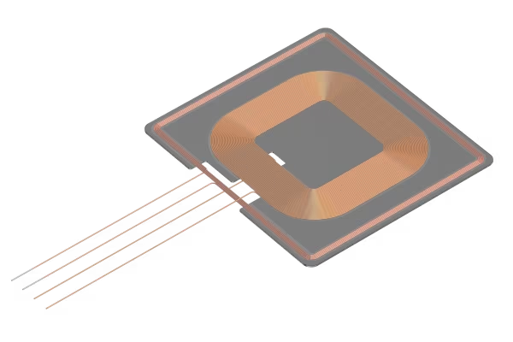

**Table of Contents**

Page 03 – Design Problems and Objectives

Page 04 – Detailed Design Documentation

Page 16 – Laboratory Test Plans and Results

Page 17 – Bill of Materials

Page 18 – Gantt Chart

Page 19 – Ethical Considerations

Page 20 – Safety

Page 21 - Conclusion

Page 22 – Acknowledgements

Page 23 – References

Page 25 – Appendices

**Design Problems and Objectives**

Our goal for the PCB design element of this project is to create a custom PCB with an integrated NFC antenna that is capable of longer-than-average-range data transfer and interface it with power modularity. Our NFC readers will interface with a ATMega2560 microprocessor, common cathode multicolored LED lights, power supply, and power transfer nodes. All these elements, combined with a custom 3D printed exterior, will come together and create a display shelf that scans NFC based collectable figurines and changes the colors of the LED lights accordingly. This will require multiple iterations of custom PCBs, custom programming, and many iterations of 3D modeling work.

The NFC based collectable figures we are using are Nintendo’s amiibo. Our reasoning behind using amiibo is because we don’t want to enable the ability to collect private or secure data from other NFC chips, such as credit cards, key fobs, and security devices. The amiibo figurines feature an NTAG215 NFC chip that stores data unique to each figure. We will take the unique data from the amiibo and use it determine what figure is currently being scanned. We will then compare it to a database that will return the correct color of lighting for that specific figure.

**Detailed Design Documentation**

We began our project with some general ideas and took some time to decide what we wanted our project to be. Austin suggested we create a sort of display case that has the ability to scan toy figures and display them in the case. We all liked this idea and wanted to figure out how we can incorporate electrical engineering concepts into a project like this. The pictures below show the physical housing for this display case as well as the concept sketches. We decided to go with a box design that can house 3 figures at once and is made up of white plastic with a grey outside. One of our main reasons for going for a two-tone design is that it is more visually appealing, and the white plastic on the inside is the best for allowing light to pass through it.

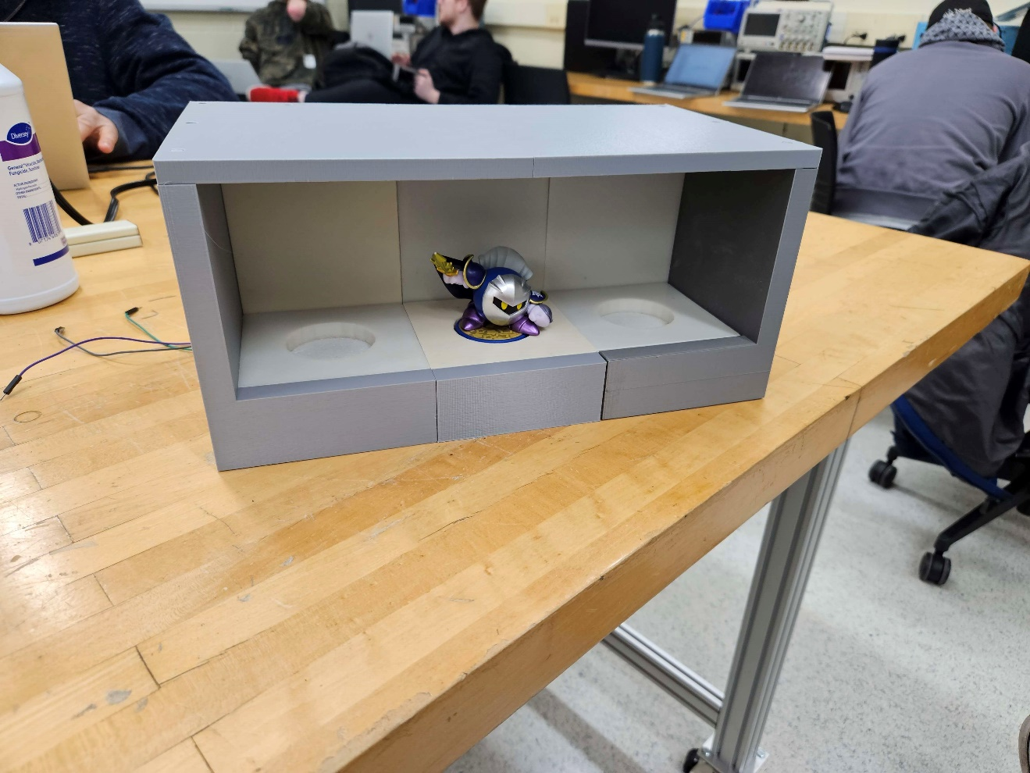

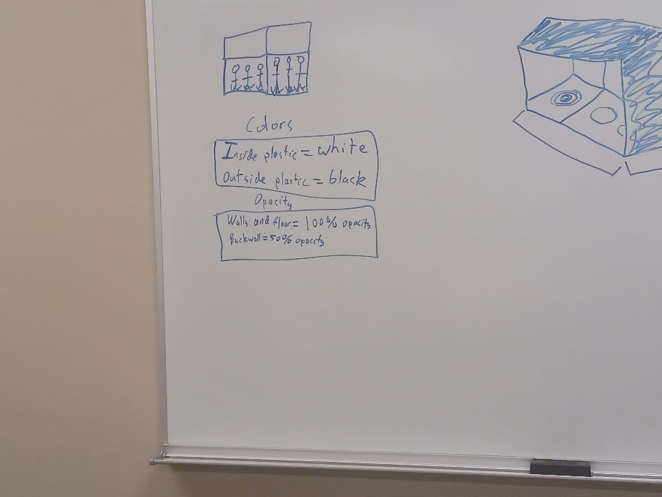

Below shows some rough dimensions and early stages of what we envisioned the project would look like.

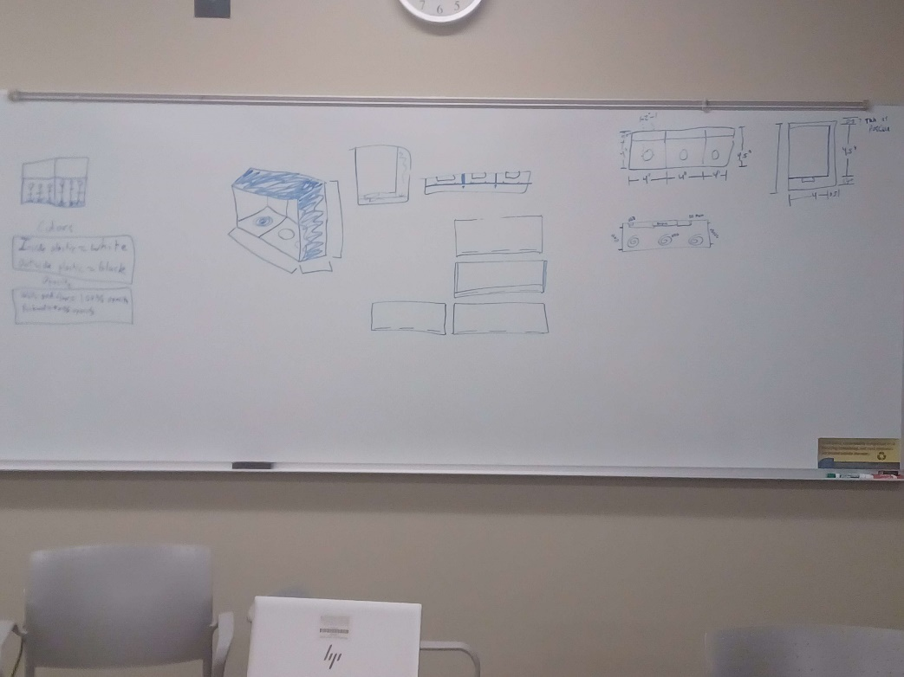

The photo below was used to sketch out the rough electrical design and ensure that we had the same vision and direction for our electrical design. It shows a side angle of the housing, as well as some drawings of our early stages of how we imaged our power transfer feature could be used as well as how the NFC boards would interact with the amiibo.

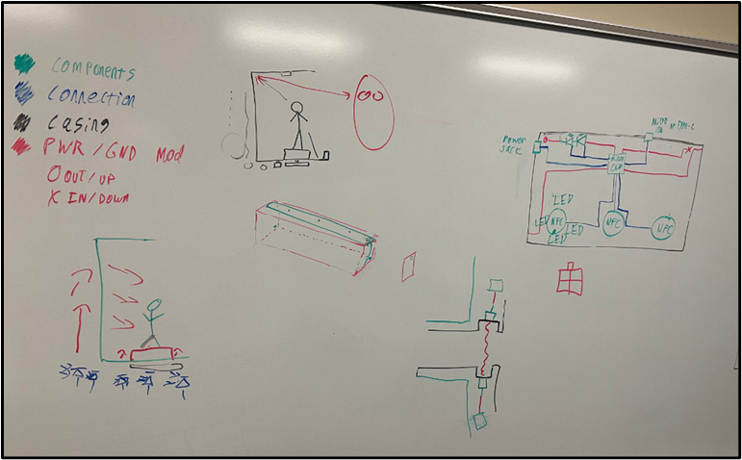

We decided that when a figure is scanned, it’s unique figure data from the NFC tag will be used to light up an LED which has the same color scheme as the figure. There are many things you can do with NFC data depending on what type of chip you are using and the application. Because we decided not to build our antenna with the ability to scan credit card data and personal safety devices, we thought showing LEDs would be a simple and useful method of showing the user that the NFC data is being read. The easiest way to achieve this would be to use a multicolor LED, and began researching them. We learned there were 2 types of LED lights, a common cathode and a common anode. We determined a common cathode would be the best fit as we need to supply different voltages to the RGB pins which is easier to do using a common cathode LED.

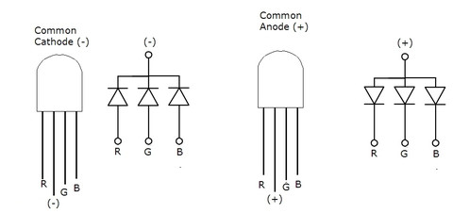

As we have mentioned, the figures we decided to use are amiibo. Amiibo are a product from Nintendo which have an NTAG215 chip inside of that both read and store their own unique data.

We can read the data from the amiibo through wireless data transfer as long as it is within range of an NFC antenna. Researching how NFC antennas work ended up being the main focus of our design for our first semester. We determined that a CLRC663 chip would be the best for our uses as it is specifically for reading and processing data being received from an NFC antenna. We incorporated this chip into our custom PCB and looked into the schematic to find out how the CLRC663 operates.

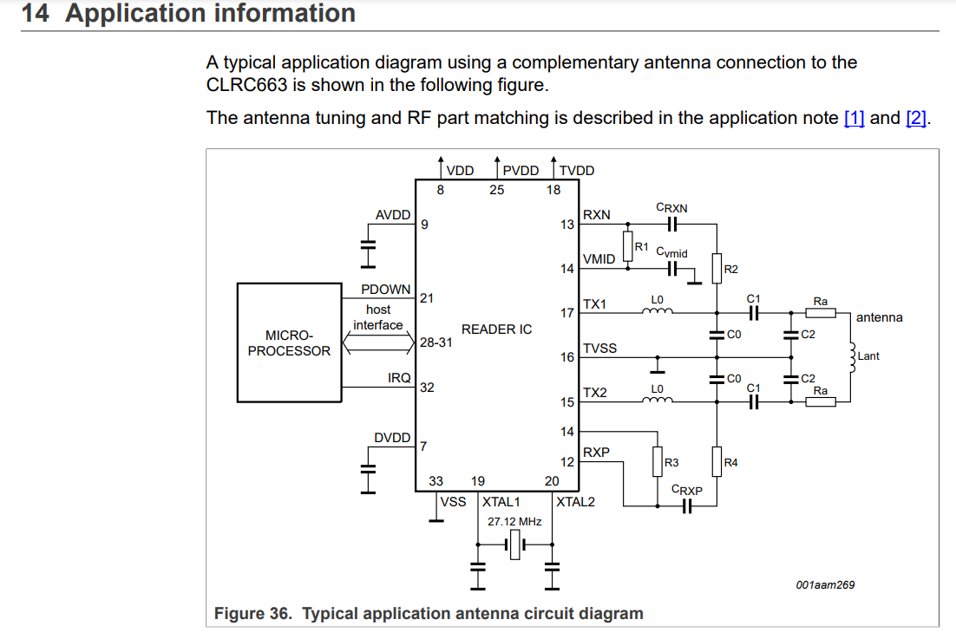

**Early Conceptual Stages of the Custom PCB:**

When we started to research the NFC antenna, we knew this would end up becoming a long journey, and so we took some time to figure out how we wanted our antenna to function and what specs it would have. The picture below shows that we originally planned to have 3 NFC antennas on a single board, all laid out next to each other (represented by the ovals in the middle) and then they will all feed into our CLRC663.

The reasoning behind this was that we could create 3 different antennas, but only scan one antenna at a time when something was placed. This will lead to saving costs on the microprocessor chips.

The picture lists an RC522 chip as that is what we intended to use at the beginning, but after doing our research learned that the RC522 chip was out of stock, and the CLRC663 is the new industry standard. Unfortunately, we later found out that the CLRC663 chip has little to no documentation (due to the fact that it is new) which has proven to be tremendously difficult in debugging the antenna and getting it to work.

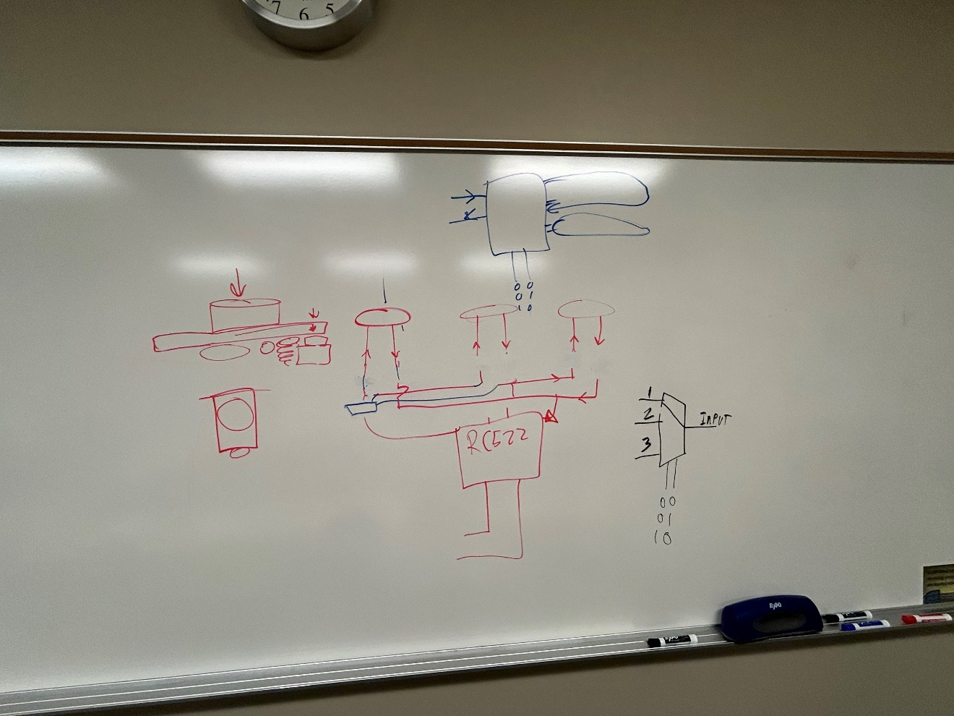

We then began to decide shows a simple design of our electrical layout. As mentioned above, we planned to have three antennas going to a small chip which will read and process the data. Shown here is also a port for micro-USB or USB-C which we will use to program our chip. We had initially considered including a DC power jack and micro-USB slot, but it was scrapped as we decided that it would be easier to just use the regular type-c connection port for ease of use.

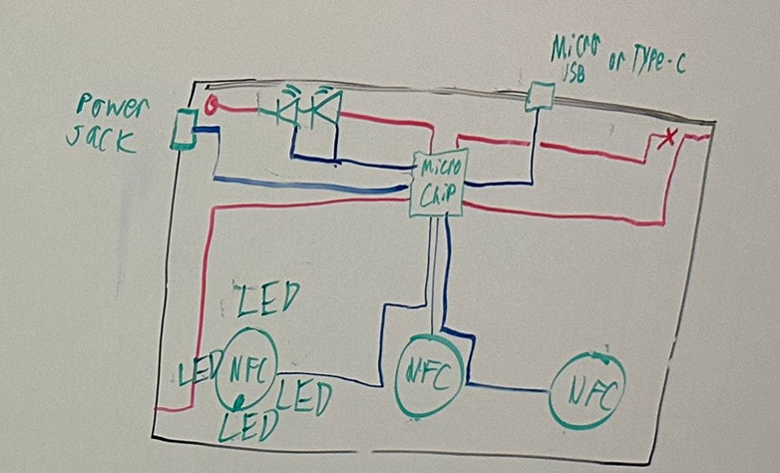

**Antenna Design Calculations:**

After we agreed on the design of our antenna PCB and the general layout, we began to start specifying parameters we wanted. To start, we needed to know what we were scanning in the first place. In order to get data transferred from the NFC tag into our NFC antenna we needed to know what frequency the NFC tag from the amiibo figure could operate at. We learned that the figure has an NTAG215 chip inside of it which is able to transfer data at 13.56Mhz.

After doing some research we found that an ST25TB or ST25TV series antenna had the required tunning frequency necessary for our needs. We initially thought maybe we could use either one but learned that the ST25TV Series would not work with the NTAG215 chip found in the amiibo figures. We decided to go with the ST25TB series antenna and used the following table as a reference for when we began our calculations going forward.

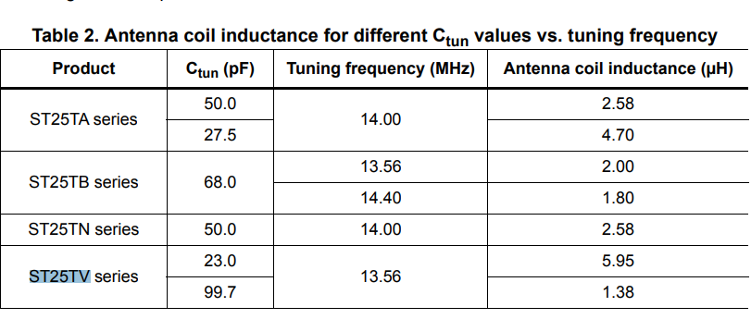

The picture below shows our product parameters for the NTAG215 chip.

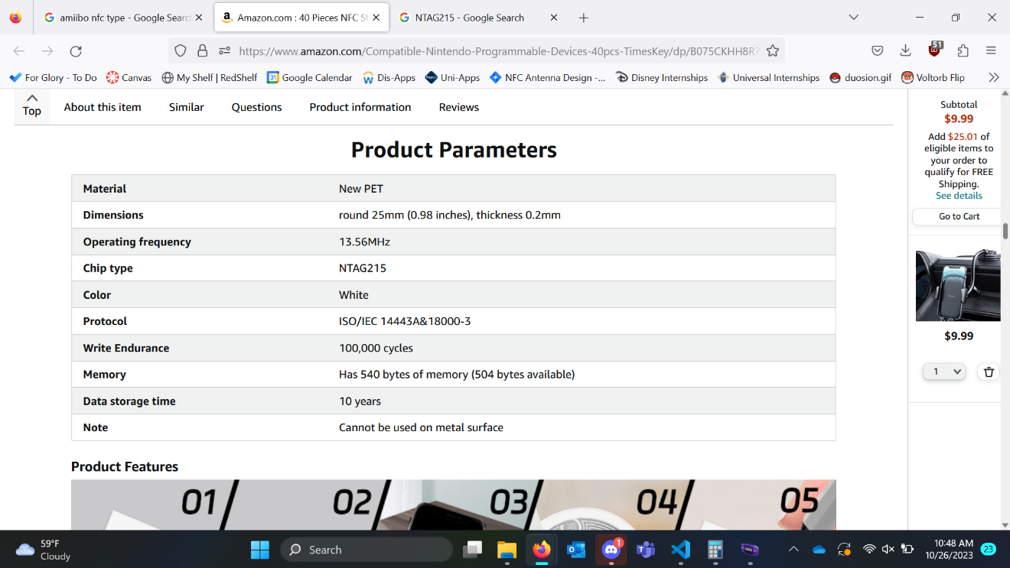

**Deciding on the Shape of the Antenna:**

After we had ironed out the scope for some of our parameters, we began learning about how different antenna shapes affect data transfer and the accuracy of the data being received. Our research determined that the two leading designs for an NFC antenna would be either a circle or a square. A circle design has less data loss, but the square design has more stability. Due to the limitations of our PCB design software, we decided we could not do a circle design. We had planned to use a sort of hybrid design, with an octagonal shape similar to the one in the middle of the photo below but figured out while doing our calculations that the geometry on a PCB would be rather difficult when going with this approach and would only lead to marginal gains. We ended up making a square design with rounded edges which will give nearly similar results, but not quite as ideal as a full octagon would have been. The benefit, though, of going with our design is that it made the calculations more accurate.

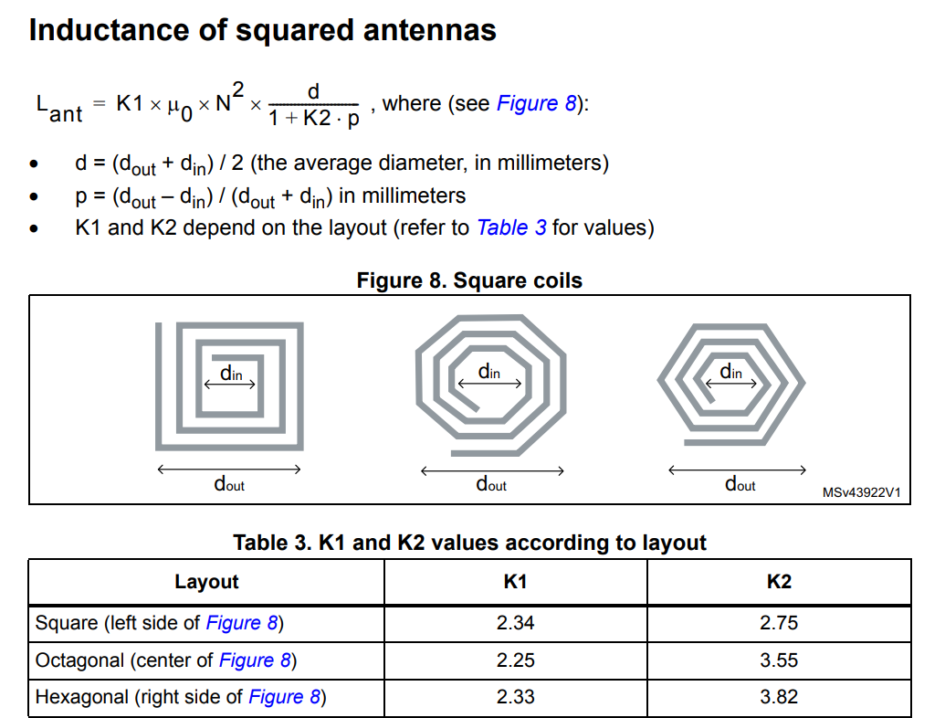

**Finding Our Ideal Operating Range/Distance:**

To find our ideal operating range we referenced NXP’s antenna documentation and were able to find the two graphs below and decided that we would aim for a 4cm-diameter antenna which will give us a ~3cm distance to scan our NFC tag.

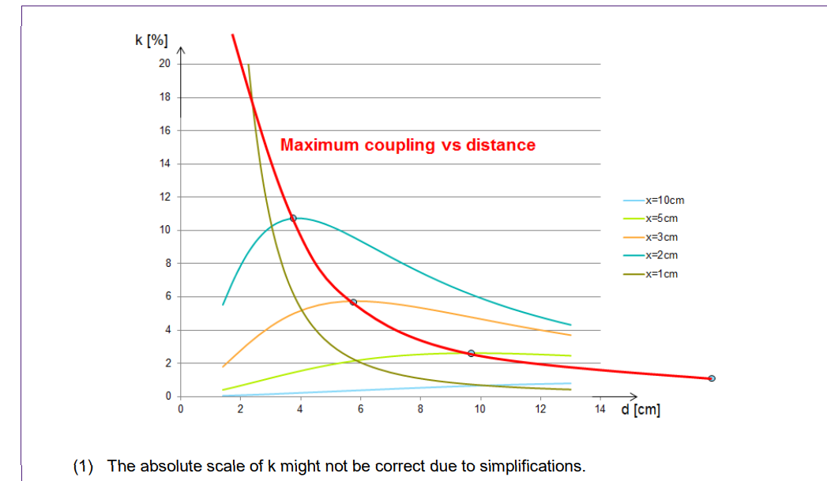

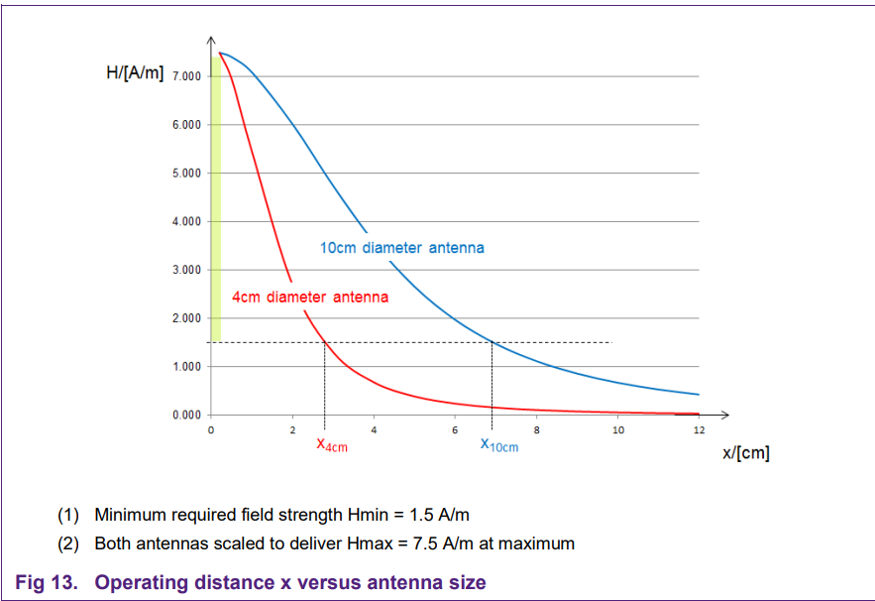

**Early Antenna Design Equations and Parameter Calculations:**

After we had decided upon an operating range, the size of the antenna we wanted, and the shape of the antenna we wanted, we started to research and look up the necessary equations and information we would need in order to calculate the components needed for the antenna. We knew that our EMC filter was static and that the matching circuit had to be tuned in the smiulation to give us the result we wanted. From here, we decided to focus on figuring out the actual antenna values. We were able to find out the internal resistance of the coil for the antenna by taking the restivity of copper and multiplying it by the length of the coil of wire and dividing it by the cross sectional area of the overal wire. Pictured below are two visual representations of us figuring out the length and cross sectional area of the antenna, as well as creating a formula to find out what one extra turn of wire would add onto the problem.

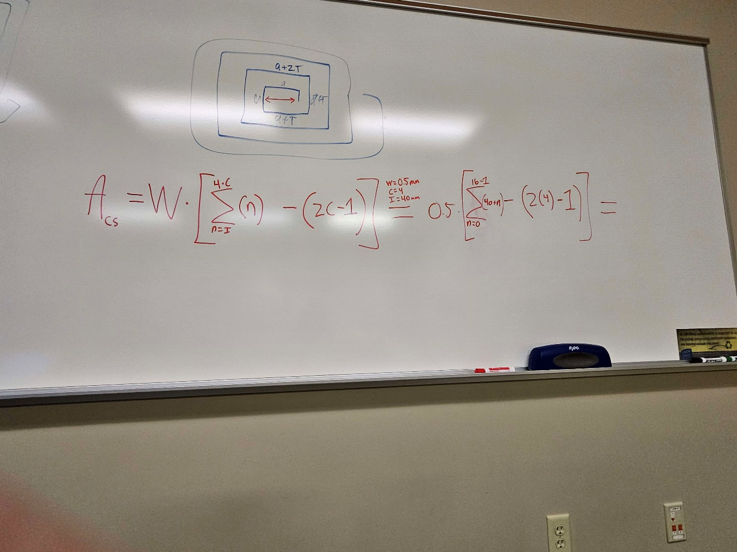

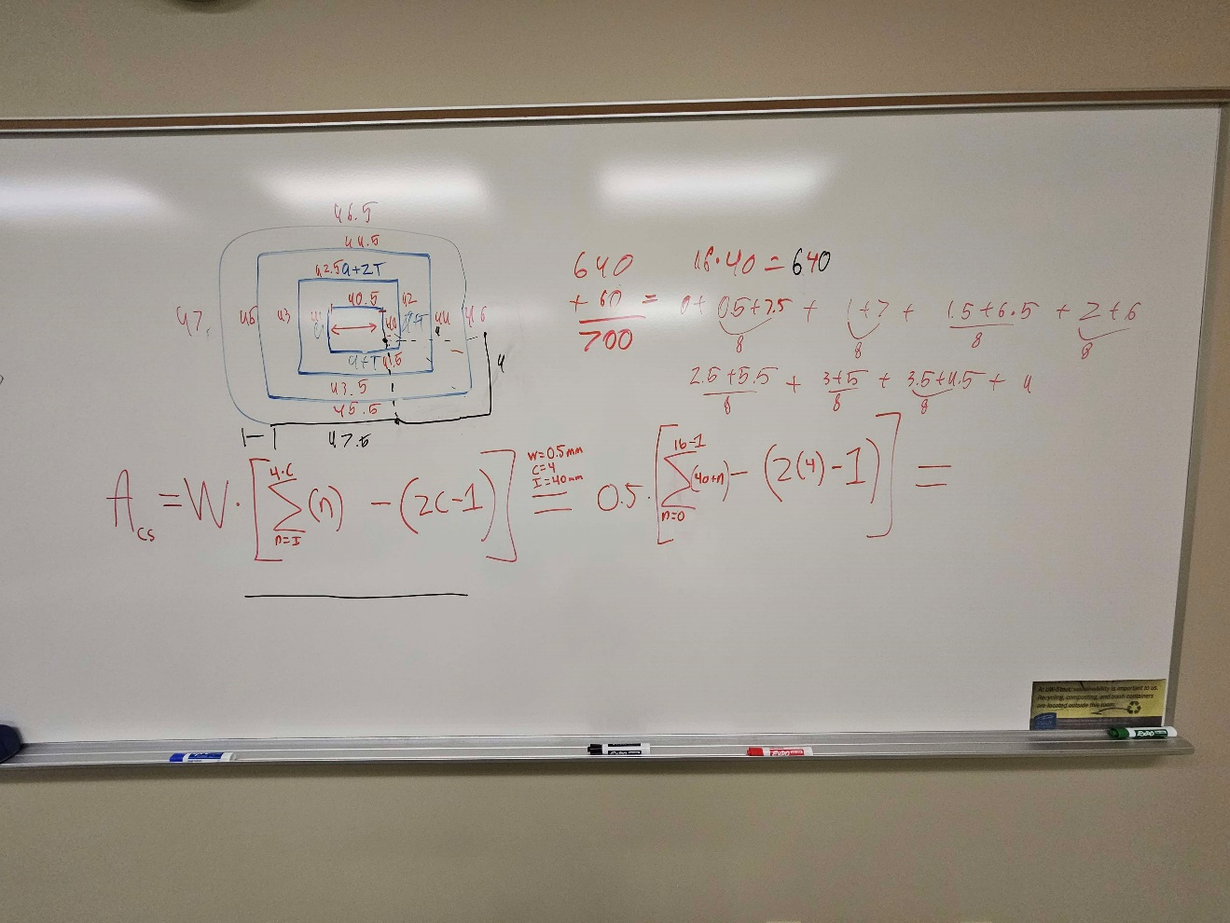

After calculating the resistance of the antenna, we were able to find out the inductance of the antenna by using the number of turns, coupling coefficients, resistance of the antenna, and diameter. From the inductance we were then able to find the capacitance. Next, we went over to an online antenna calculator software we found to verify that our calculated values were correct according to the specifications we made.

**Double Checking our Calculations:**

We managed to find an online calculator and decided to use it as a resource to double check our calculations and ensure that they were in the same ballpark as what we got. After inputting the correct information, we found out that our calculations were indeed correct.

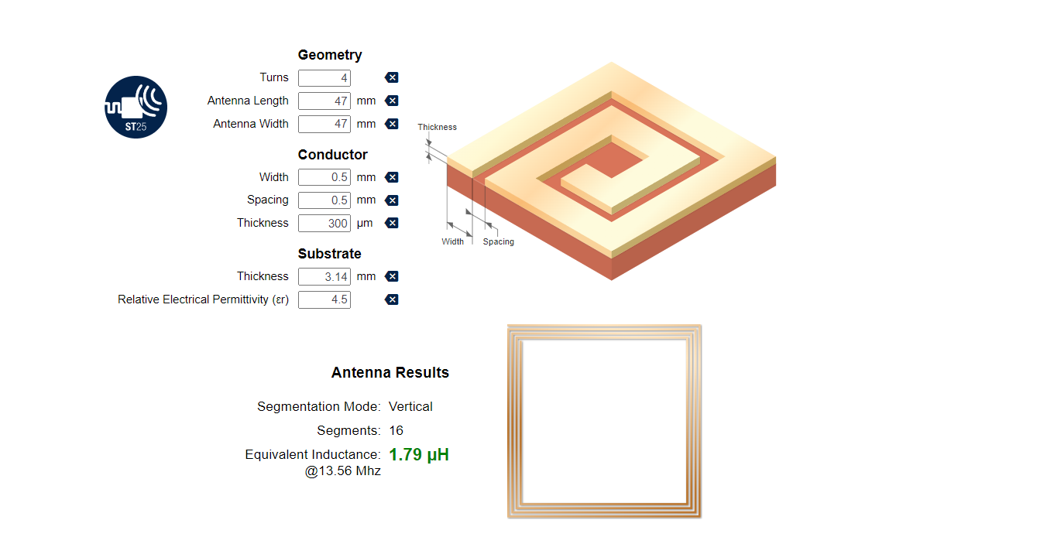

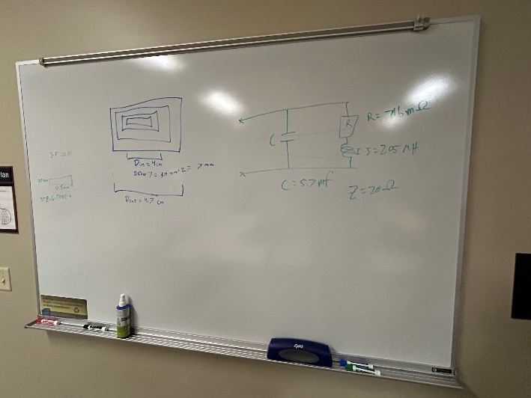

Our complete antenna circuit drawn out with our calculated values can be seen below.

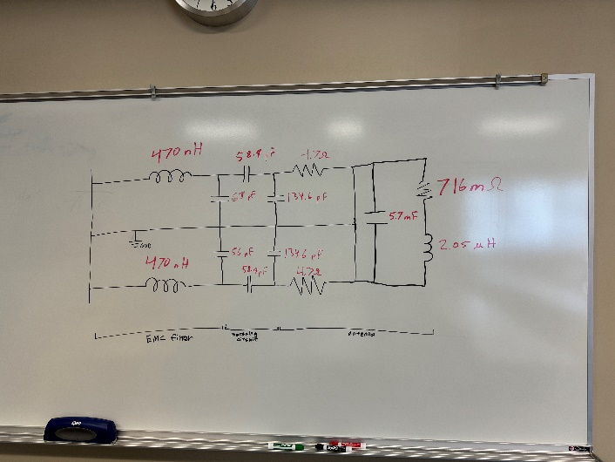

Upon verifying that our values were correct, we next moved onto creating a working simulation using RFSim99 to start testing the operating range of the antenna. We originally copied over our values from our excel sheet and placed them into the simulation software. However, upon simulation we recognized with the smith chart (pictured below with a green line) that our antenna was in theory working, but its data transfer was going to be terrible. This is where we started to work on optimizing the matching circuit values to ensure our data transfer was not going to experience any interference.

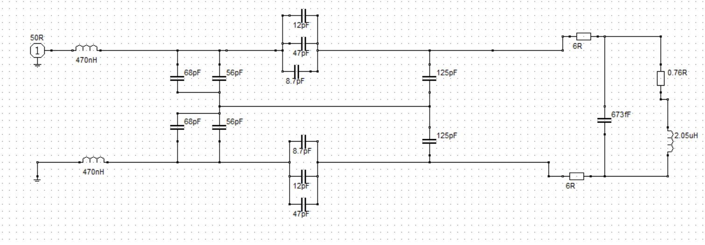

The graph below is a photo of our Smith Chart which is the chart that is used to simulate antennas. The green line is the ideal location at which data transfer works the best and the red line is the range at which our antenna can achieve. The closer to the green line the better. The blue colored section shows the ideal range at which the antenna can operate. Our red line is the product of our calculations and values. As can be seen, our point is close to both of them which shows that we are in good standing for our antenna working.

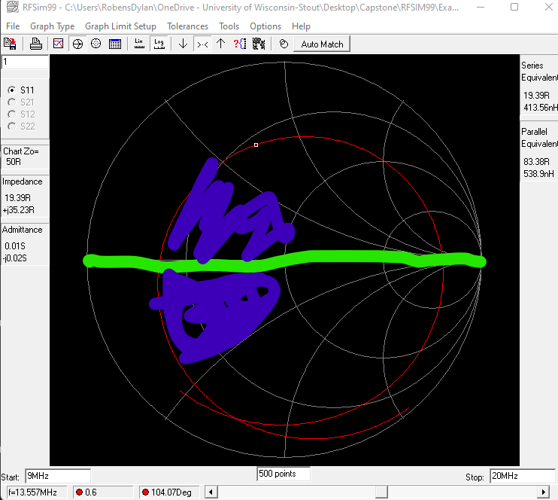

**NFC Reader PCB Design:**

The schematics shown in the photo are created using the supplier recommended circuit for the CLRC663 as well as conventional standards for NFC antenna circuits. We ended up discovering that utilizing 0-ohm resistors to reduce EMF within our circuit was the best way to achieve the best possible data transmission. We also made sure that we brought out the pins from the CLRC663 to add an extra layer of debugging capability when we move onto the physical testing phase in the second semester.

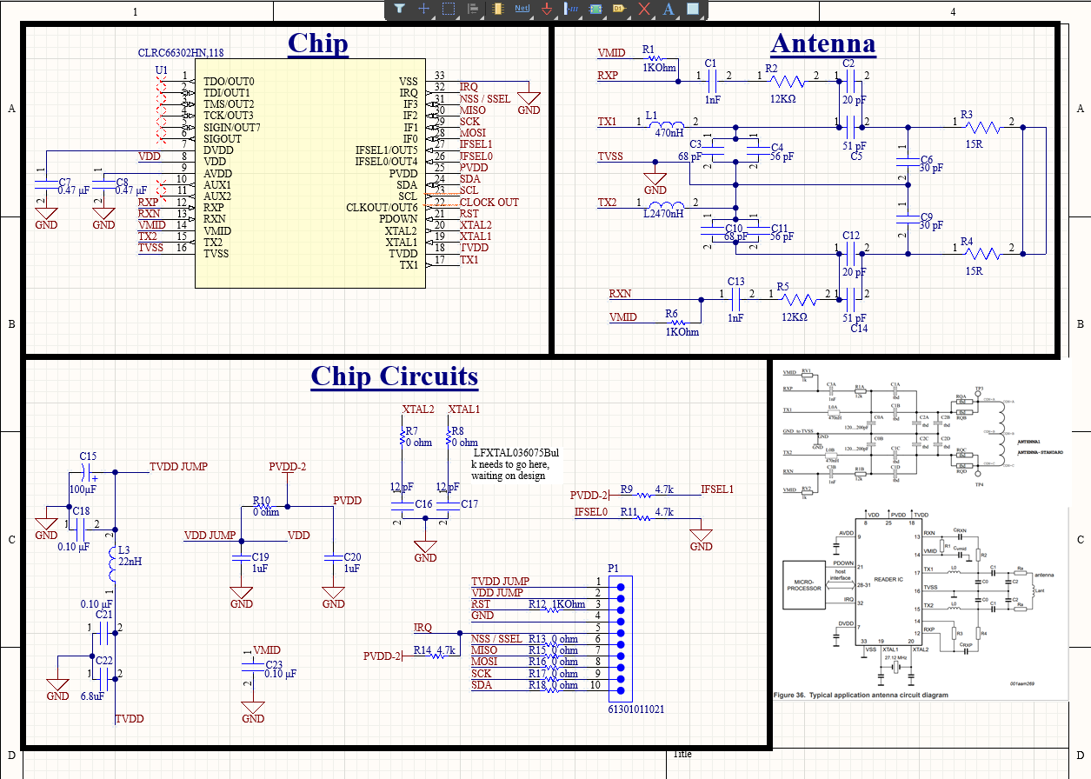

Below is the finished design that incorporates the previous circuit logic as well as our completed antenna design. This is what will be sent to the manufacturer for creation:

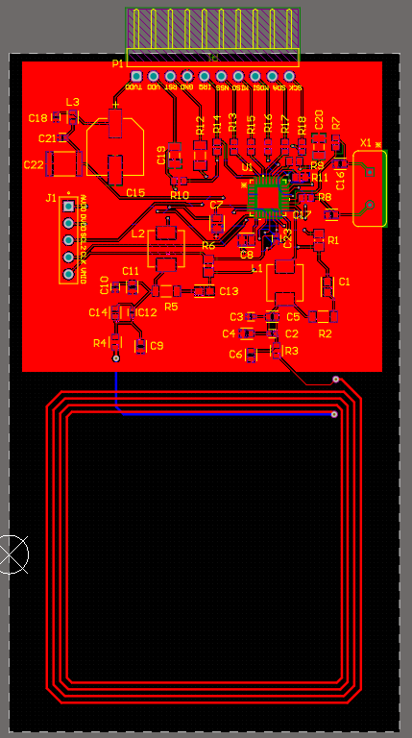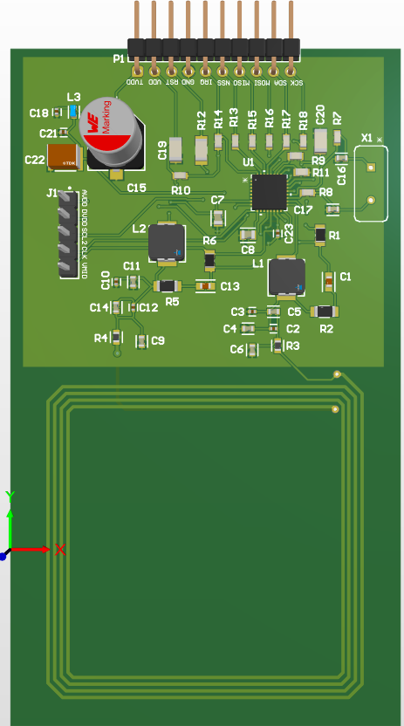

**Custom Motherboard PCB Design:**

Below is a custom motherboard that we designed and created using the original Arduino 2560 schematic as a reference. The main things that we changed about this board are the headers that we use to interface with the NFC readers, LEDs, and various other electronic devices present within our final design. To reduce the cost of the system overall and increase the amount of available space, we removed the extra headers that were not needed for our device that we were creating. We opted for this design choice instead of purchasing an Arduino Uno, as we needed the extra memory that the Arduino Mega 2560 had onboard.

*Main Microcontroller Circuit*

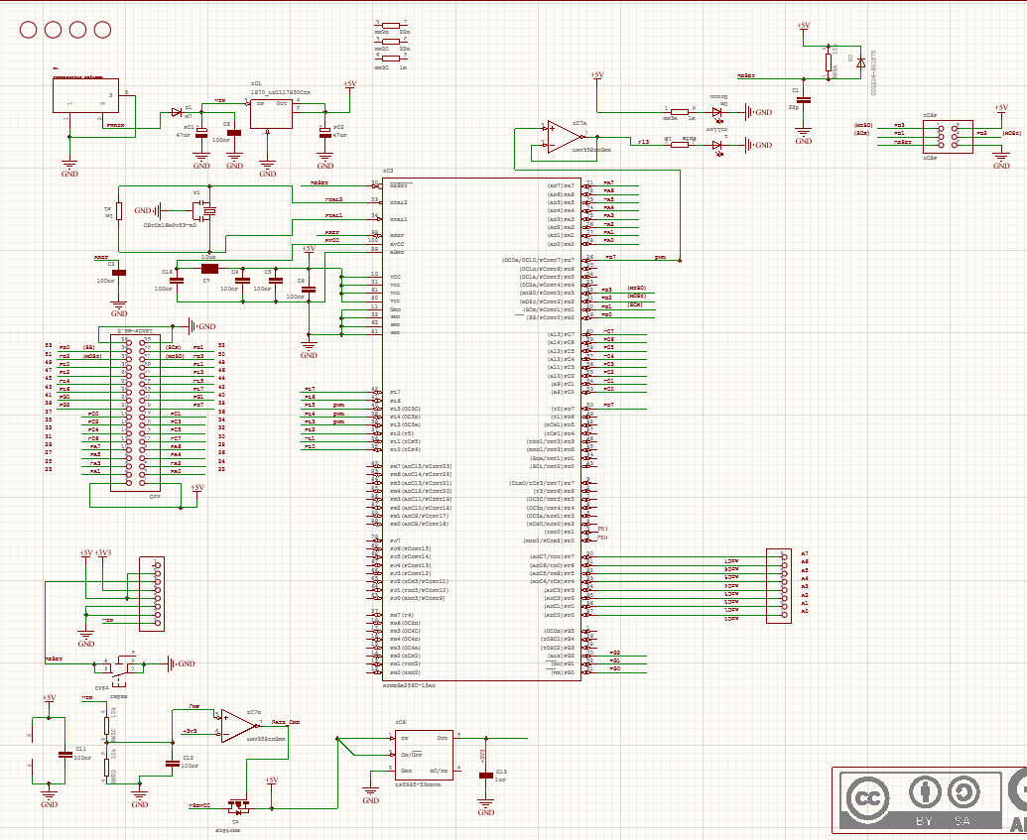

*USB Controller Circuit*

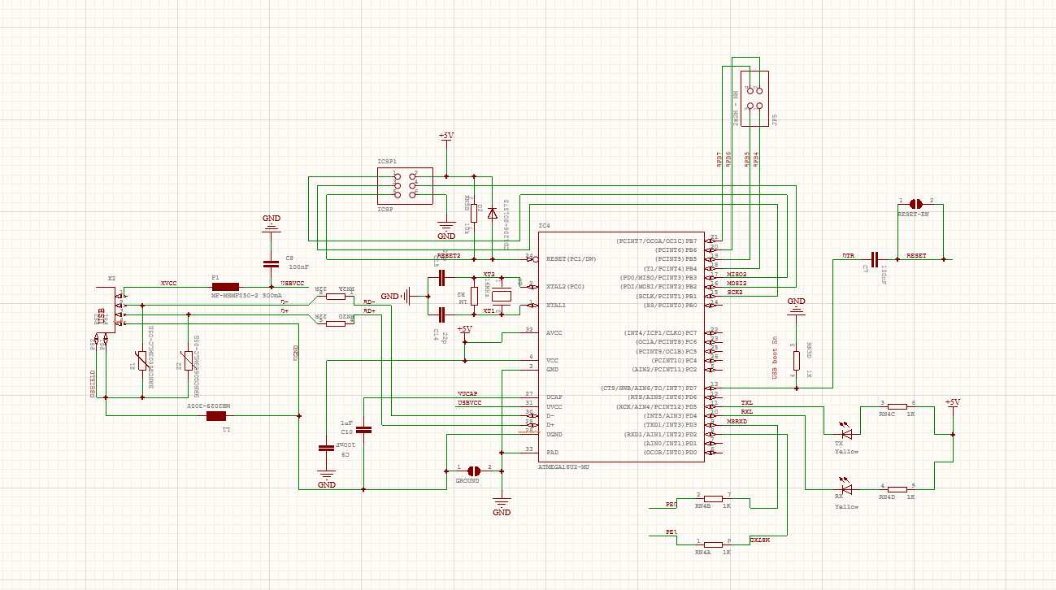

Below is the finished design our custom Arduino Mega 2560 within Altium designer. This is what we sent to JLCPCB for manufacturing:

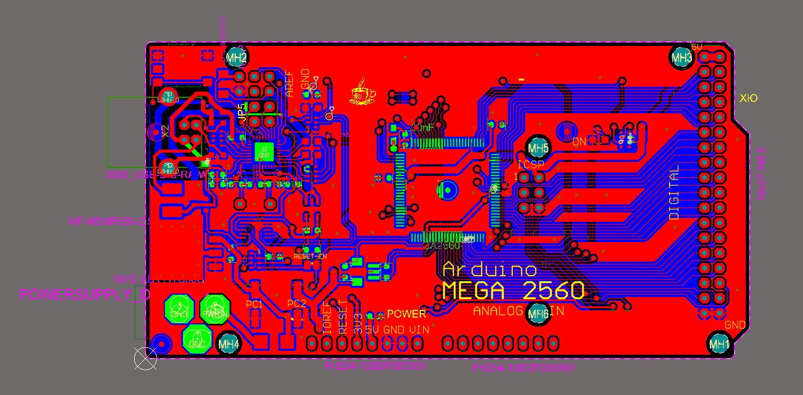 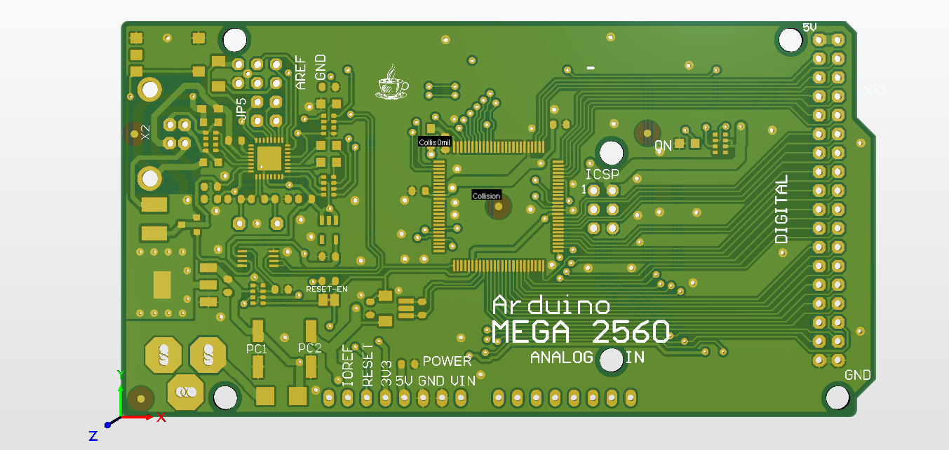

**PCB Fabrication**

After having designed our PCBs we then sent them to JLCPCB, a PCB manufacturing company, to have them fabricated. After uploading our schematics to the company, we were then required to order the components either internally from JLCPCB, or externally by globally sourcing the parts through other manufacturers. At this stage of the project, we were met with a multitude of issues as we went through this process. When globally sourcing the parts from different manufacturers, we encountered multiple shipping delays that pushed back our project even further into the semester. While this was expected, we didn’t expect it to happen as frequently as it did, and this led to the manufacturer not having parts that were in stock previously at the time of order.

We primarily encountered this issue when ordering our first PCB, which was the NFC antenna board. After having first ordered the parts that would be required for the board, it took over a month for those parts to be shipped to the JLCPCB manufacturing site. This led to parts that were previously in stock at the JLCPCB manufacturing site being out by the time we were ready to order. Due to this, we experienced delays in receiving our NFC antenna boards and as a result have had less time to test and debug them than we would have liked. We experienced this issue with the custom Arduino Mega Boards that we created, too, but to a lesser degree as we preordered parts that were low ahead of time.

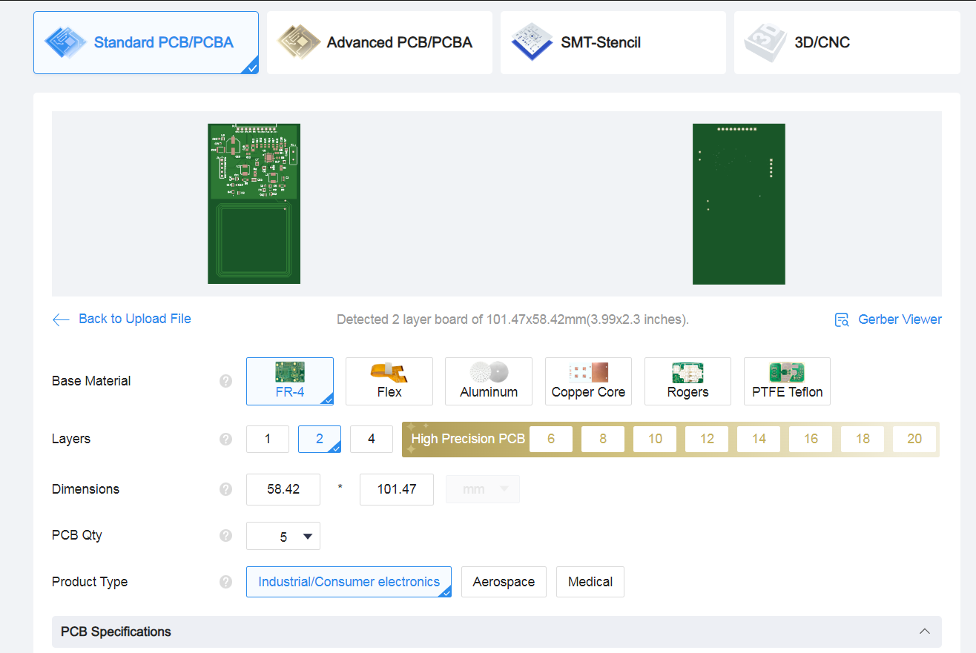

**PCB Fabrication Results**

After We received our custom NFC antenna boards, we began testing them and noticed that they do not operate as expected. Due to the limited open-source code that’s available on the internet for the particular chipset that we used, we were unable to get the boards to function as expected. If we were given further time to debug these boards and possibly rework the design itself, we would have a better opportunity to make a functioning board that works as our simulations show they should. With that being said however, we were able to read registers that exist on our NFC Reader PCB. In order to get this board fully working however, we would have to purchase a development board which we do not have the budget, or the time for.

We also encountered issues with JLCPCB when we ordered our custom Arduino Mega. JLCPCB incorrectly placed a lot of the IC’s and microchips that were present on the board. Due to the naming conventions that we used; the manufacturer incorrectly assumed that a lot of the parts had an orientation that didn’t matter. This led to the board not functioning as expected and being completely unusable with our project. If more time was allotted, we would be able to debug these boards and fix a multitude of these issues that are present.

Below are pictures of the finished NFC Reader and the Arduino Mega 2560 PCBs.

*NFC Reader PCB*

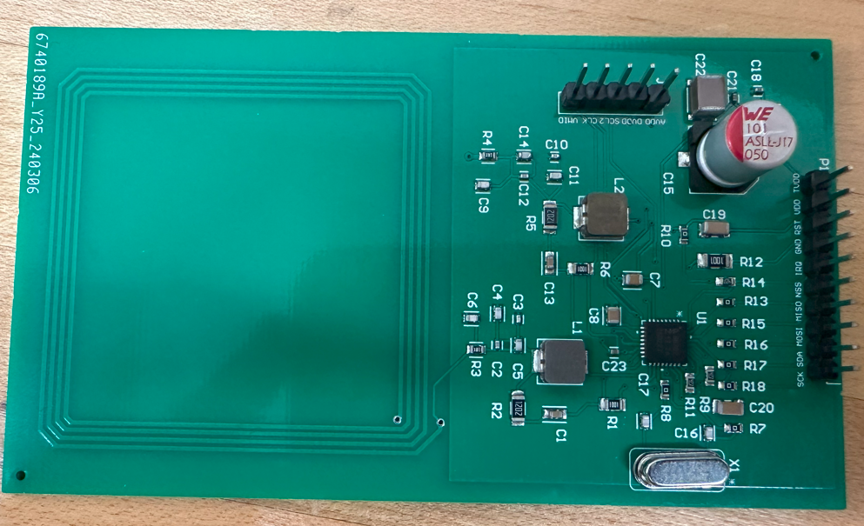

*Arduino Mega 2560 PCB*

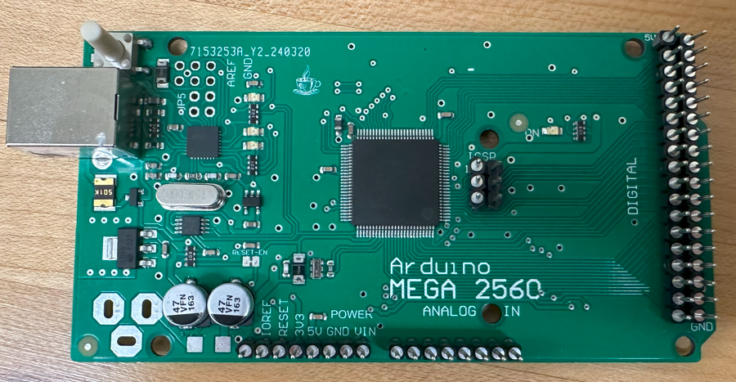

**3D Modeling**

While the PCBs were being made in Altium, we also began working on the necessary housing in which the NFC antennas would rest in. Our plan was for the amiibo figures to have a visually appealing shelf-like housing so they wouldn’t just be resting on a large antenna with a bunch of wires visible.

The original prototype consisted of 11 individual files that would need to be printed to complete one full shelf. The general concept was that there would be a slot in which the amiibo figures would rest in and a back screen that would hide all the wires and LED lights. We also made the shelf easily constructable without the need for any tools, this was because we didn’t want to have to assemble and disassemble a shelf multiple times whenever a issue was present. Our shelf parts slid on and off easily and constrained the shelf in a physically secure.

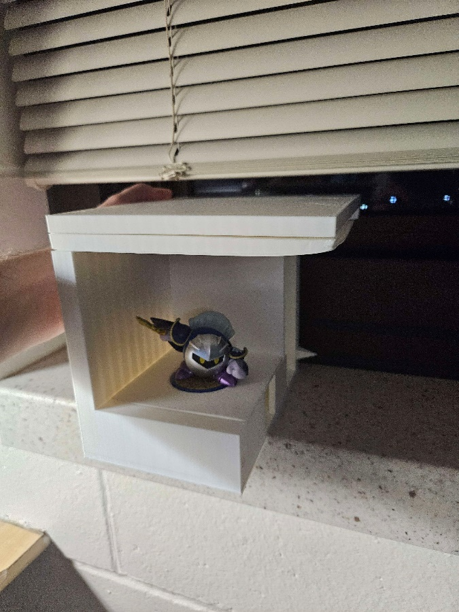While printing, the physical structure of some of the parts was extremely thin, this led to warping which became a problem for longer prints when and caused many prints to fail over time due to the warping. We also were originally using our own 3D printer to make everything which constrained when we needed to finish our design by. However, we were informed about the printing lab on campus and that we couldn’t order more PLA for our own printer. We had to go through the 3D printing lab in order make more prints there. With that we refined our design and removed a few of the parts that were redundant and made existing parts more robust so they wouldn’t warp. While printing, we also encountered some issues with removing supports in very tightly cramped places and so we removed any instance that would create supports that were troubling to remove. However, we managed to make a proof of concept with the original 3D printer and files we had.

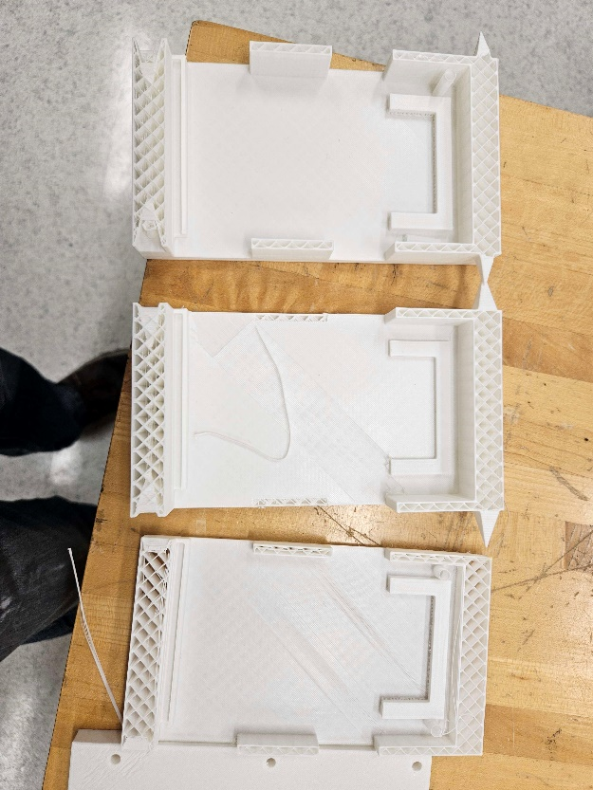

The second prototype didn’t vary much from the final design with the only major changes being a slot for a photo resistor, and a slot for the NFC boards on the amiibo slots.

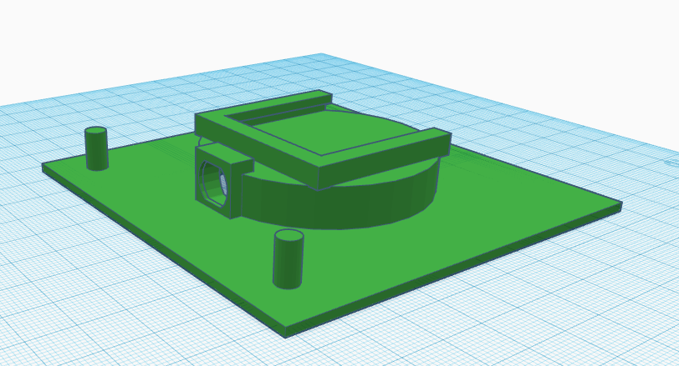

Once we received the prints from the 3D print lab, we constructed the first working prototype. We had all of it put together near perfectly and began testing the code we had prepared. By this time, we knew what minor things needed to be changed with the design and quickly changed them so we could send out the files for the final design of the shelf.

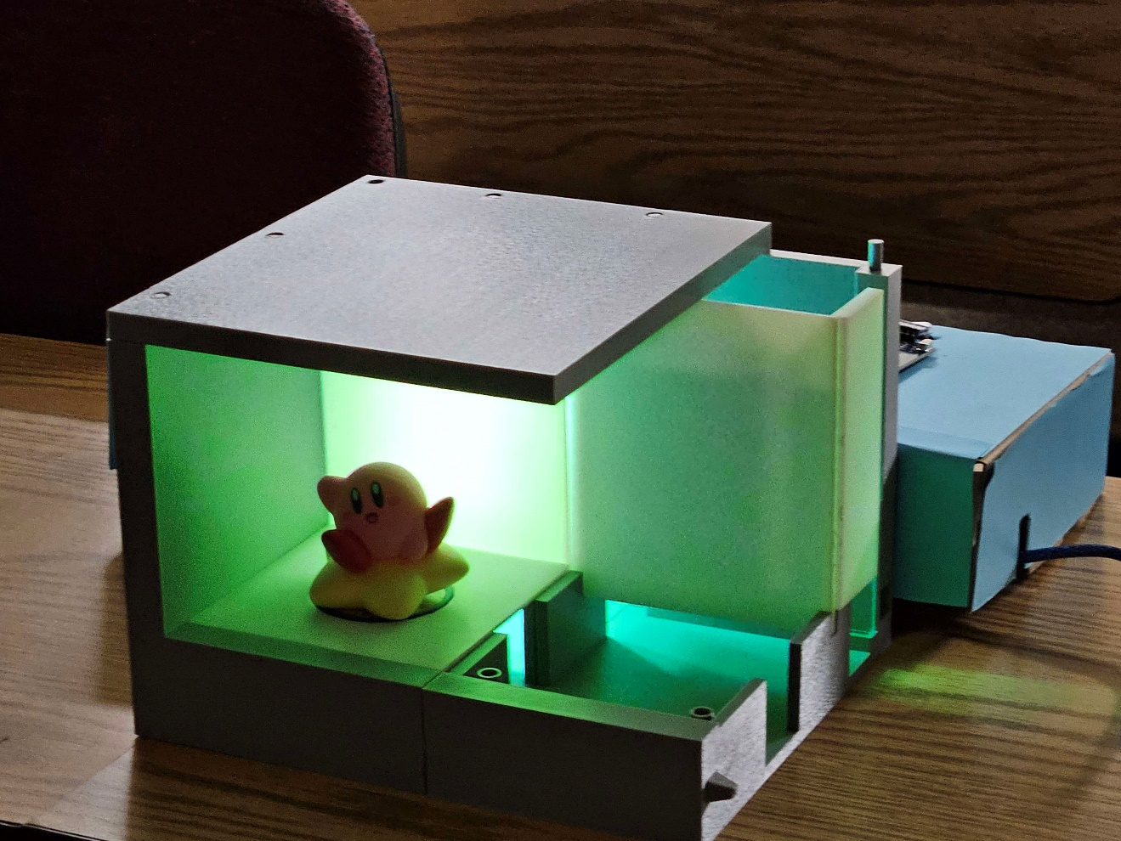

The final 3D printed shelf design of our project can be seen in the photo below:

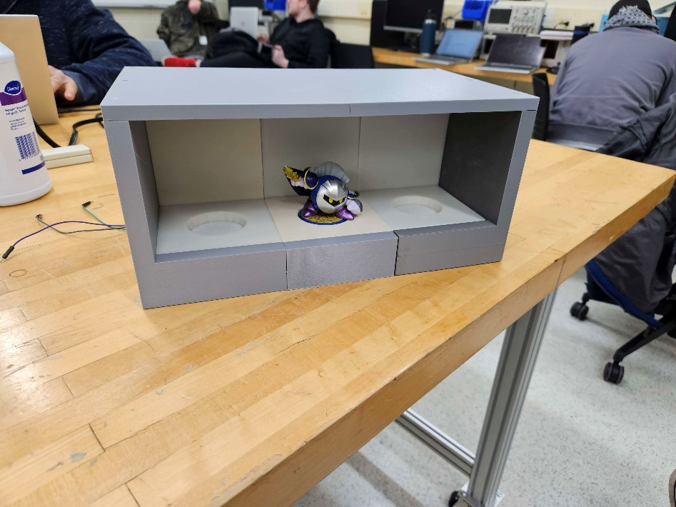

**Arduino Software**

While in the planning stages for our software, we determined that storage space would be an issue due to the large number of figurines we wanted our software to be compatible with. We also decided early on that we wanted to use an Arduino-based motherboard as our microcontroller, as this was a device that we were all very familiar with. This constraint is what ended up leading us to the Arduino Mega, which had more than enough space to store all of the head, tail, and color values for each figure.

One of the goals with our software was to split each sensor we had into its own class. That way, we could individually test each component to make sure it was functioning properly. There are three main classes used in our program: one for the MFRC522 board, one for the photoresistors, and one for the LED logic. The MFRC522 and LED lights we purchased both had recommended libraries we could use to interact with them, which was very helpful in the programming process. This meant that we could focus on new aspects of our program, rather than learning how an external device functioned. The Photoresistor class was custom made, and although simple, was extremely helpful in making the code clean and concise.

Our main loop that runs the device checks each photoresistor to see if one has dropped below a preset light threshold. This means a figure has been placed inside of a slot. If that is the case, then it reads the figure, takes the received data, and searches for a match within our database. It then returns that match and changes the LED lights accordingly. Once a figure has been placed, the program checks if the photoresistor exceeds a preset threshold. If it has, then a figure has been removed from a slot. The program then simply turns off the respective lights and waits for a new figure to be placed.

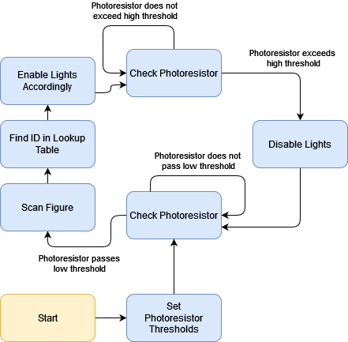

**Bill of Materials**

manufacturer, part number, part description, supplier, quantity, and cost

*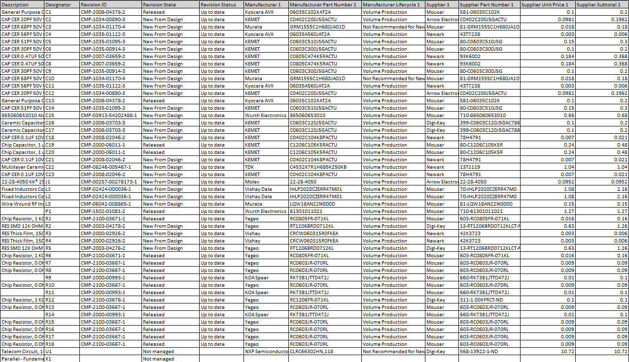NFC Reader BOM*

* Arduino Mega 2560 BOM*

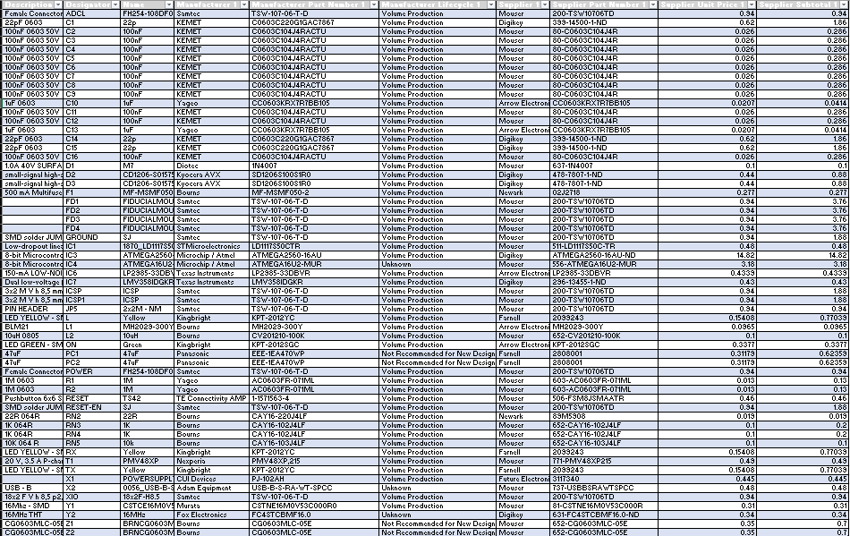

**Gantt chart**

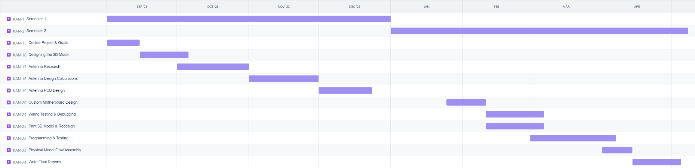

**Alex -** PCB Design, Testing, Final Report

**Dylan -** PCB Design, Testing, Shroud Creation, Final Report

**Austin -** Code Design, Prototype Testing, Final Report

**Joaquin -** PCB Design, Code Design, Prototype Testing, Final Report

**Ethical Consideration**

Although our project poses no danger or ethical concerns to people, we are interacting with a piece of proprietary technology created by a multi-billion-dollar company. It is very important that we are not infringing on any copyright or trademark by Nintendo and its subsidiaries. This only applies to the code created to interact with the amiibo figures, which are distributed by Nintendo. Most of the amiibo data is not encrypted, including the 2 “pages” (four bytes each) of data used by our program. However, pages 40 to 130 are encrypted by a private data key owned by Nintendo and is not released to the public. Using this key would directly be a violation of Nintendo’s copyright and could cause legal trouble. Thus, we do not violate ethical codes as we do not use this data key.

We also make use of multiple open-source libraries and programs throughout our project. Some of these libraries, such as the NFC library, are completely free to use and redistribute. Other libraries, such as Adafruit’s NeoPixel, are free to use but cannot be redistributed. This means that we would be unable to distribute our final program without it also being open source. This is not an issue as we would distribute the program as open source as is, but it is important to note within our Ethical Consideration.

**Safety**

When it comes to safety in our design, our goal is to provide as little points as possible for an individual to interact with the electronics in our project. What this looks like is designing a shroud for the electronics that will allow for the antenna to still scan the NFC chip that will be placed close to the antenna. This way, we will be able to still maintain the optimum functionality of the device while reducing the amount of risk that the user will experience.

In terms of the antenna design, we will be designing the antenna so that it will only operate at a specific frequency of 13.56 MHz. This will remove the ability for the antenna to scan other chips that aren’t operating at the same frequency and therefore prevent the stealing of data that the system isn’t designed for.

**Conclusions**

This project introduced us to many concepts of antenna design, PCB design, and 3D modeling. We all learned a lot of new information about these topics that we only touched the surface on in previous college courses.

As far as the antenna design goes, we learned that there are many things that go into designing filters for the data, as well as determining proper dimensions of the antenna to reach the preferred range requirements. In addition to that, we also needed to learn about how different shapes of the antenna coil would affect the readability and quality of the data being received.

The other major conclusion we were able to make when designing the antenna is that the diameter of the antenna is directly proportional to the field strength of the antenna, as well as the number of turns in the antenna being directly proportional to the field strength of the antenna. So we decided to do multiple turns and a larger diameter antenna so we could have a field strength that would hopefully reach out 2cm from the board. (*AN11019*)

After having finished the antenna design and implementing it on a PCB, we have learned a lot about the design process behind these antennas and how to effectively test your design to make sure it works. Through our experience using RFSIM99 and the built in Smith chart, we learned how effective and important these simulations are to create a design that works as expected. If we would have had even more time and resources to continue the research behind the antenna design featured in our PCB, we are confident that we could have developed a product that worked as expected and even exceeded our expectations.

The actual design aspect of the PCB went smoothly. We had prior experience from our curriculum courses and internships that allowed us to feel confident using Altium Designer to create our PCBs. Once we had our design created, the issues arose with the fabrication company, JLCPCB. They did not have the parts that were present within our design, meaning we had to globally source them from other companies around the world. After a back and forth that went on for about a month and a half, we were finally able to order our design and get it assembled and shipped to Stout. This whole ordeal increased production time and delayed our project well beyond the dates we were originally expecting and reduced the amount of time overall that we had with our boards. JLCPCB also incorrectly placed some of our parts due to naming convention issues which unfortunately make our custom motherboard completely unusable.

Lastly, our 3D printed model taught us a lot when it comes to mechanical and physical design engineering. We went through multiple different iterations to reduce supports, increase structural strength, and ensure the whole thing fits together nicely. We had to account for space tolerances and try to maximize the amount of usable space while making the shelf not extremely huge and bulky. We also had to create walls that could support various loads, walls that could allow light passthrough, and baseplates that would be thin enough to allow data transfer with our NFC antennas and chips.

**Acknowledgments**

Professor Liu Cheng – PCB Design Advice

Professor Ahmet Turkman – Project Design Advice

James Kopp – Antenna Design Advice

NXP – Antenna Design Procedures and Calculations

Kevin Brewster – amiibo Reverse Engineering Documentation

**References**

NXP. “Training - Mobileknowledge.” *NFC Reader Design: How to Build Your Own Reader*, Feb. 2015, [www.themobileknowledge.com/wp-content/uploads/2017/05/NFC-Reader-Design-How-to-build-your-own-reader.pdf](http://www.themobileknowledge.com/wp-content/uploads/2017/05/NFC-Reader-Design-How-to-build-your-own-reader.pdf).

NXP. “NFC Reader Design 2 - Antenna Design Considerations.” *NFC Reader Design 2 - Antenna Design Considerations | NXP Semiconductors*, 13 Oct. 2016, www.nxp.com/video/nfc-reader-design-2-antenna-design-considerations:DESIGN-NFC-APPLICATIONS.

Affendi1, N. A. M., and M. Amirruddin1. “IOPscience.” *Journal of Physics: Conference Series*, IOP Publishing, 1 May 2021, [https://iopscience.iop.org/article/10.1088/1742-6596/1878/1/012024/pdf](https://iopscience.iop.org/article/10.1088/1742-6596/1878/1/012024/pdf#:~:text=The%20higher%20the%20gain%2C%20the,3.514%20dB%20at%20900)

*NTAG213/215/216 NFC Forum Type 2 TAG Compliant IC with 144/504/888 ...*, June 2015, [www.nxp.com/docs/en/data-sheet/NTAG213_215_216.pdf](http://www.nxp.com/docs/en/data-sheet/NTAG213_215_216.pdf)

Phillips Semiconductors. “13.56 MHz RFID Proximity Antennas .” *BAS*, 8 Nov. 2002, nic.vajn.icu/PDF/nfc/Mifare/Mifare_13.56_MHz_RFID_Proximity_Antennas.pdf

Merz, Christian. “Impedance Matching for NFC Applications.” *EE Times Europe*, 7 Jan. 2022, [www.eetimes.eu/impedance-matching-for-nfc-applications/](http://www.eetimes.eu/impedance-matching-for-nfc-applications/)

easyELAB. “How RFID Works? And How to Design RFID Chips?” *YouTube*, YouTube, 21 Dec. 2018, [www.youtube.com/watch?v=FwbWvjq_iiM](http://www.youtube.com/watch?v=FwbWvjq_iiM)

Ham Radio Guy - G0KSC. “How to Model Antennas with 4NEC2 Antenna Modelling Software - Part 1, the Basics.” *YouTube*, YouTube, 30 Nov. 2020, [www.youtube.com/watch?v=W2N8AeOFqaM](http://www.youtube.com/watch?v=W2N8AeOFqaM)

Merz, Christian. “Impedance Matching for NFC Applications: Part 2.” *EE Times Europe*, 16 Dec. 2021, [www.eetimes.eu/impedance-matching-for-nfc-applications-part-2/](http://www.eetimes.eu/impedance-matching-for-nfc-applications-part-2/)

Merz, Christan. “Impedance Matching for near Field Communication Applications.”, 10 Dec. 2020, [www.we-online.com/catalog/media/o207264v410%20ANP084a%20EN.pdf](http://www.we-online.com/catalog/media/o207264v410%20ANP084a%20EN.pdf)

NXP. *High Performance Multi-Protocol NFC Frontend CLRC663 and CLRC663 Plus*, July 2021, [www.nxp.com/docs/en/data-sheet/CLRC663.pdf](http://www.nxp.com/docs/en/data-sheet/CLRC663.pdf)

NXP. AN11019 “CLRC663, MFRC630, MFRC631, SLRC610 Antenna Design  Guide.” 18 June 2018, [www.nxp.com/docs/en/application-note/AN11019.pdf](http://www.nxp.com/docs/en/application-note/AN11019.pdf)

NXP. *AN11145 CLRC663, MFRC631, MFRC 630, SLRC610 Low Power Card Detection*, May 2015, [www.nxp.com/docs/en/application-note/AN11145.pdf](http://www.nxp.com/docs/en/application-note/AN11145.pdf)

Barksdale, David. “Rfidbadge.” *GitHub*, github.com/amatus/rfidbadge/blob/master/CLRC663.cpp. Accessed 12 Dec. 2023.

OSSLibraries, Rotzbu. “Osslibraries/Arduino_mfrc522v2.” *GitHub*, 17 Oct. 2020, github.com/OSSLibraries/Arduino_MFRC522v2

**Appendices**

**(Excel Doc with Antenna Specific components calculated)**

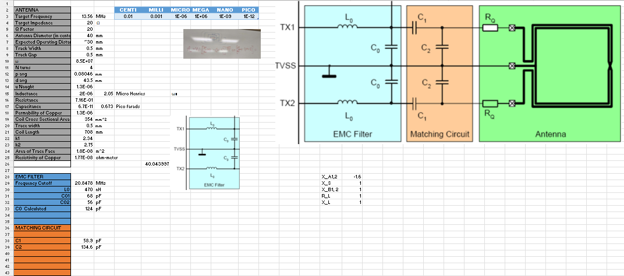

**(Simulated Antenna Results after tuning the matching circuit to the Antenna)**

